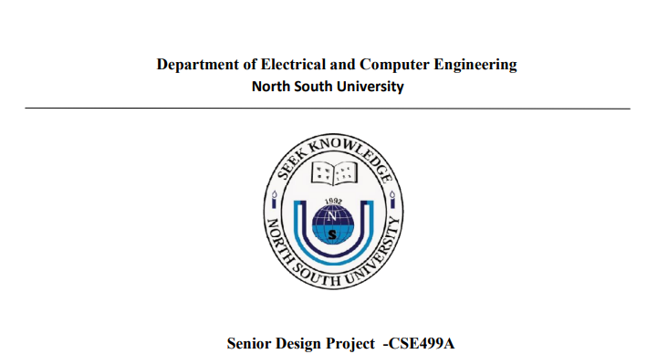

**Related Papers**

**Covid-19 and Viral Pneumonia Detection Using Deep Learning**

**Name: Jannatun Nayem**

**ID :1821896642**

**Paper Link : https://www.mdpi.com/2075-4418/12/12/3171**

**This research paper focuses on COVID-19 detection using pre-trained models for feature extraction, primarily utilizing X-ray, CT scan, and ultrasound images. X-ray images are the preferred method for identification in most studies. Various pre-trained models such as VGG19, AlexNet, ResNet, and others were employed as feature extractors, achieving high accuracy rates. For instance, VGG19 yielded 95% accuracy, while ResNet-34 achieved an impressive 98.33% accuracy. Transfer learning techniques were also employed, with models like ResNet-101 and Xception obtaining exceptional results, reaching 99.51% and 99.02% accuracy, respectively. The study further demonstrated the effectiveness of ensemble learning and self-transfer learning models, showcasing their potential in improving classification accuracy. Overall, the paper highlights the significance of pre-trained models in enhancing the efficiency of COVID-19 detection from medical images.**

**Paper Link : https://www.mdpi.com/1660-4601/20/3/2035**

**This research paper addresses the critical need for swift and reliable diagnosis of COVID-19, which has affected millions globally. The study highlights the limitations of primary detection methods like RT-PCR, emphasizing the potential of Computed Tomography (CT) scans and chest X-rays as more accurate alternatives. While CT scans offer high accuracy, chest X-rays are a faster and cost-effective diagnostic tool, albeit with concerns about radiation exposure. The paper discusses the application of Deep Learning, particularly Convolutional Neural Networks (CNNs), in analyzing chest X-ray images for COVID-19 detection. Several studies have demonstrated promising results using CNN architectures like CheXNet and other pre-trained models, achieving accuracy rates of approximately 99%. However, the study acknowledges limitations, including finite datasets and a lack of external evaluation data. The research conducts a comparative evaluation of five state-of-the-art deep learning models on a comprehensive COVID-19 CXR dataset. Results indicate high precision and recall scores, with ResNet101 emerging as the top performer. The study concludes by outlining future goals, including lung segmentation, ensemble modeling, and collaboration with professional radiologists to further enhance the system's diagnostic capabilities. The research underscores the potential of individual deep learning models in COVID-19 identification and highlights avenues for future improvement and clinical integration.**

**Paper Link : https://www.mdpi.com/2079-7737/10/11/1174**

**The research paper focuses on the development of an automated deep learning-based model for rapid COVID-19 detection using chest X-ray images. The study is conducted by a team from various academic institutions across different countries. They address the urgency for reliable diagnostic methods due to the global impact of COVID-19.The dataset employed in the study consists of 3616 COVID-19 chest X-ray images and 10,192 healthy chest X-ray images, which are further augmented. The researchers evaluate eleven existing CNN models for detecting COVID-19 symptoms, with MobileNetV2 showing promising results and being chosen for further modification. This modified model achieves the highest accuracy of 98% in distinguishing COVID-19 and healthy chest X-rays.The paper emphasizes the significance of accurate screening methods to swiftly detect COVID-19, thereby reducing exposure for healthcare professionals. The proposed method outperforms existing approaches, showcasing its efficacy in identifying infection symptoms from chest X-ray images.Additionally, the study provides a comprehensive review of related research, highlighting various deep learning models and their respective accuracies in COVID-19 detection using chest X-rays. The authors note that while some models achieve high accuracy, they often use limited datasets, potentially affecting generalization.In response to this, the authors propose a modified MobileNetV2 model trained on a large dataset of 52,000 augmented chest X-ray images. This model demonstrates both high accuracy and efficiency, with a notably short compilation time. The credibility of the model's outcome is validated through statistical tests.Overall, the paper presents a novel deep learning-based approach for COVID-19 detection from chest X-ray images, offering a highly accurate and swift diagnostic tool to aid in the fight against the pandemic.**

**Paper Link :** <https://www.mdpi.com/1424-8220/21/17/5940>

**This research paper, authored by experts from Jordan University of Science and Technology, focuses on the crucial need for accurate and accessible diagnostic tools for COVID-19. They utilize deep convolutional neural networks (CNNs), a form of artificial intelligence, to detect COVID-19-related pneumonia in chest X-ray images. The study involves the collection of chest X-ray images from 368 confirmed COVID-19 patients, along with data from three publicly available datasets. The CNN models are evaluated in four different scenarios, demonstrating a remarkable detection accuracy of 98.7% when using the combined dataset. Importantly, the models are also evaluated with a completely foreign set of images, revealing only a minimal drop in accuracy. The paper emphasizes the potential of AI systems in aiding radiologists to accurately diagnose COVID-19-related pneumonia, especially in areas with limited access to specialist knowledge. Furthermore, the paper provides an extensive review of related work, highlighting various methods and models employed for COVID-19 detection using chest X-ray images. The authors stress the importance of large, diverse datasets in training and testing AI models to ensure reliable outcomes. In conclusion, the research paper offers a valuable contribution to the field of COVID-19 diagnostics by showcasing the effectiveness of deep CNN models and emphasizing the potential of AI applications in healthcare, particularly during global health crises.**